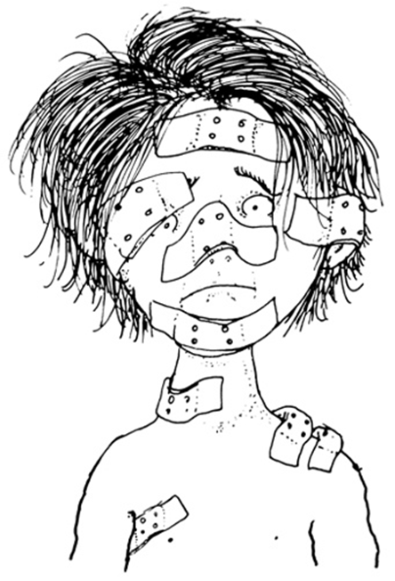
Band-Aids
by Shel Silverstein
I have a Band-Aid on my finger,
One on my knee, and one on my nose,
One on my heel, and two on my shoulder,
Three on my elbow, and nine on my toes.
Two on my wrist, and one on my ankle,
One on my chin, and one on my thigh,
Four on my belly, and five on my bottom,
One on my forehead, and one on my eye.
One on my neck, and in case I might need em
I have a box of thirty-five more.
But oh! I do think it's sort of a pity
I don't have a cut or a sore!
Where the Sidewalk Ends, 1974

